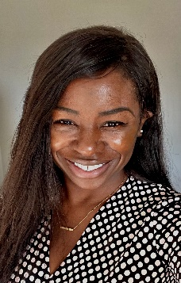

Dear Esteemed Monte Sano Community,

I hope this message finds you well. It is with great pleasure that I introduce myself as the Assistant Principal of Monte Sano. My name is Jovanghn Parks, and I am thrilled to join our community.

My educational journey includes a Specialist of Education degree in Curriculum and Instruction (December 2005), a Master of Education in Elementary Education (May 2004), and a Bachelor of Arts in Education with a focus on Elementary Education (May 2003), all earned at the University of Florida in Gainesville.

Professionally, I bring four years of experience as an Assistant Principal in elementary education. I am also a proud participant in the GSLA Aspiring Principal Program (2023-2024 cohort), and my passion lies in early elementary education. Over the past 19 years, I have had the privilege of contributing to both national and international teaching and leadership endeavors. Most of which was gained in an elementary school setting!

As we embark on this academic journey together, I am committed to fostering a collaborative and supportive environment. My door is always open, and I look forward to getting to know each of you better.

Please feel free to reach out to me with any questions, ideas, or concerns. Let’s work together to create an inspiring and enriching educational experience for our students.

Monte Sano Elementary School Assistant Principal

Jovanghn Parks

Parksjo@boe.richmond.k12.ga.us